Experiment No. 1

Aim: Implement Linear and Logistic Regression on real-world datasets

Dataset Source
Two real-world datasets obtained from Kaggle were used for this experiment.

Dataset 1 (Linear Regression)
- Name: Global Air Quality Dataset
- Description: Contains air pollution and meteorological data collected from urban locations
- Source:https://www.kaggle.com/datasets/smeet888/global-air-quality-data15-days-hourl y-50-cities
- File Used: globalAirQuality.csv

Dataset 2 (Logistic Regression)
- Name: Heart Disease Dataset
- Description: Contains medical attributes used to predict the presence of heart disease
- Source Link: https://www.kaggle.com/datasets/johnsmith88/heart-disease-dataset ● File Used: heart.csv

Dataset Description

Dataset 1: Global Air Quality Dataset
The dataset contains measurements of atmospheric pollutants and environmental parameters.
Features Used:
- pm25 → Particulate Matter 2.5

- pm10 → Particulate Matter 10

- no2 → Nitrogen Dioxide

- so2 → Sulfur Dioxide

- o3 → Ozone

- co → Carbon Monoxide

- temperature

- humidity

- wind_speed

Target Variable (Linear Regression):
- AQI (Air Quality Index) – Continuous value

Dataset Size: Approx. 18,000 records
Characteristics:
Real-world environmental data with missing values, which were cleaned using mean imputation.

Dataset 2: Heart Disease Dataset
This dataset contains medical records used for classification.
Features Used:
- age

- sex

- chest pain type

- resting blood pressure

- cholesterol

- maximum heart rate

- ECG results

Target Variable (Logistic Regression):
- target

○ 1 → Heart disease present

○ 0 → No heart disease

Dataset Size: Approx. 300 records
Characteristics:
Binary classification dataset with numerical features.

Mathematical Formulation of the Algorithms

Linear Regression
Linear Regression predicts a continuous target variable:
y=β0+β1x1+β2x2+⋯+βnxny = \beta_0 + \beta_1 x_1 + \beta_2 x_2 + \dots + \beta_n x_ny=β0 +β1 x1 +β2x2 + ⋯+βn xn Where:
- yyy → Predicted AQI value

- x1,x2,…,xnx_1, x_2, …, x_nx1 ,x2 ,…,xn → Input features

- β0\beta_0β0 → Intercept

- β1,…,βn\beta_1, …, \beta_nβ1 ,…,βn → Coefficients

Logistic Regression
Logistic Regression predicts a binary outcome using the sigmoid function:
P(y=1)=11+e−zP(y=1) = \frac{1}{1 + e^{-z}}P(y=1)=1+e−z1
Probability is converted to class labels using a threshold of 0.5:
- 1 → Heart disease present

- 0 → No heart disease

Algorithm Limitations

Linear Regression Limitations
- Assumes a linear relationship between features and target

- Sensitive to outliers

- Cannot model complex non-linear relationships

Logistic Regression Limitations
- Assumes a linear decision boundary

- Performance may reduce for imbalanced datasets

- Not suitable for highly non-linear classification problems

Methodology / Workflow

Linear Regression Workflow
- Load globalAirQuality.csv dataset

- Remove non-numeric columns

- Handle missing values using mean imputation

- Select AQI as target variable

- Split data into training (80%) and testing (20%)

- Train Linear Regression model

- Predict AQI values

- Evaluate using MSE and R² score

Logistic Regression Workflow
- Load heart.csv dataset

- Separate features and target variable

- Apply feature scaling

- Split data into training (80%) and testing (20%)

- Train Logistic Regression model

- Predict class labels

- Evaluate using accuracy and confusion matrix

Performance Analysis

Linear Regression Results
● Mean Squared Error (MSE) and R² score were calculated.
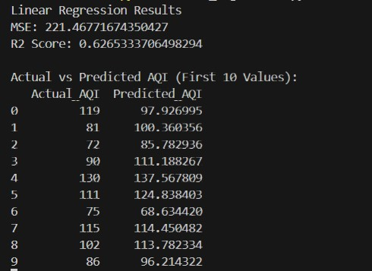

Interpretation:
The model is able to predict AQI values with moderate accuracy, indicating that pollutant and weather parameters influence air quality.

Logistic Regression Results
● Accuracy, confusion matrix, and classification report were obtained.
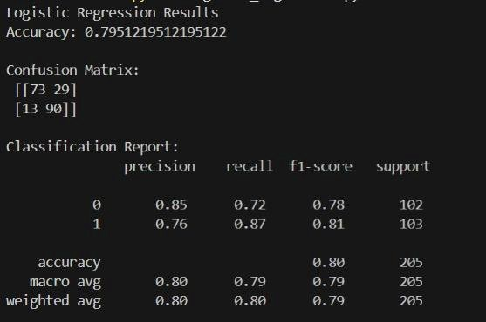
Interpretation:
The model correctly classifies patients with and without heart disease with good accuracy.

Hyperparameter Tuning
- Linear Regression:
Uses a closed-form solution; no hyperparameter tuning required.

- Logistic Regression: max_iter = 1000 was used to ensure convergence. Regularization parameter C can be tuned if required.
CODE-
import pandas as pd import matplotlib.pyplot as plt from sklearn.model_selection import train_test_split from sklearn.linear_model import LinearRegression from sklearn.metrics import mean_squared_error, r2_score import warnings
warnings.filterwarnings("ignore")
# Load dataset df = pd.read_csv("globalAirQuality.csv")
# Drop non-numeric columns df.drop(['timestamp', 'country', 'city'], axis=1, inplace=True)
# Convert to numeric & handle missing values df = df.apply(pd.to_numeric, errors='coerce') df.fillna(df.mean(), inplace=True)

# Rename target column
df.rename(columns={'aqi': 'AQI'}, inplace=True)

# Features & target X = df.drop('AQI', axis=1) y = df['AQI']

# Train-test split
X_train, X_test, y_train, y_test = train_test_split(
X, y, test_size=0.2, random_state=42
)

# Train model model = LinearRegression() model.fit(X_train, y_train)
# Prediction y_pred = model.predict(X_test)

# Evaluation print("Linear Regression Results") print("MSE:", mean_squared_error(y_test, y_pred)) print("R2 Score:", r2_score(y_test, y_pred))

# Print values in terminal comparison = pd.DataFrame({
"Actual_AQI": y_test.values[:10], "Predicted_AQI": y_pred[:10]
})
print("\nActual vs Predicted AQI (First 10 Values):") print(comparison)

Logistic_regression- import pandas as pd import matplotlib.pyplot as plt from sklearn.model_selection import train_test_split from sklearn.linear_model import LogisticRegression from sklearn.preprocessing import StandardScaler from sklearn.metrics import accuracy_score, confusion_matrix, classification_report import warnings warnings.filterwarnings("ignore")
# Load dataset df = pd.read_csv("heart.csv")
# Features & target X = df.drop('target', axis=1) y = df['target']
# Feature scaling scaler = StandardScaler()
X_scaled = scaler.fit_transform(X)
# Train-test split
X_train, X_test, y_train, y_test = train_test_split( X_scaled, y, test_size=0.2, random_state=42 )
# Train model model = LogisticRegression(max_iter=1000) model.fit(X_train, y_train)
# Prediction y_pred = model.predict(X_test)
# Evaluation print("Logistic Regression Results") print("Accuracy:", accuracy_score(y_test, y_pred)) print("\nConfusion Matrix:\n", confusion_matrix(y_test, y_pred)) print("\nClassification Report:\n", classification_report(y_test, y_pred))

Conclusion
In this experiment, Linear Regression was implemented on a real-world air quality dataset to predict AQI values, and Logistic Regression was implemented on a heart disease dataset to perform binary classification. The experiment demonstrates practical application of regression techniques, data preprocessing, model training, and performance evaluation using Python.

